Dear Sir / Madam

Thank you for the opportunity to work on the scenario-based data analysis project. Below, I have detailed my submission and the reasoning behind my approach:

**1 - Approach and Methodology**:  
I opted to complete the project using **Python** and **Streamlit** because **Streamlit** offers a dynamic and interactive platform for presenting data analysis. This framework allowed me to combine code, data insights, and visualizations seamlessly, resulting in an engaging and user-friendly report. It ensures that stakeholders can explore the data interactively, which enhances clarity and understanding of the analysis.

**2 - What I’m Submitting**:

**Streamlit Python Code**:  
I have attached the Python file that contains the complete implementation of the analysis and visualization. This will allow you to review the code for logic, methodology, and reproducibility.

**Streamlit App (Online Report)**:  
To facilitate easy access and provide an interactive experience, I deployed the analysis as a live Streamlit app. You can explore the entire report online using the following link:  
  
[**https://blank-app-7ccas6u47u3.streamlit.app/**](https://blank-app-7ccas6u47u3.streamlit.app/)

**https://blank-app-7ccas6u47u3.streamlit.app/**

**Report Screenshots**:  
For your convenience, I have included screenshots of the first and last pages of the report. These serve as a quick preview of the content and structure.

The first page of the report in a Streamlit App:

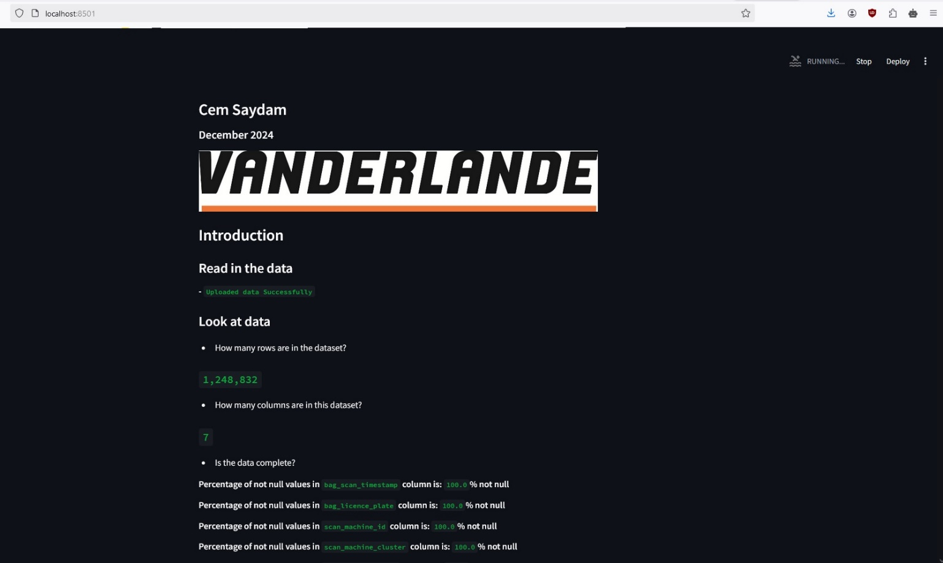

The last page of the report in a Streamlit App:

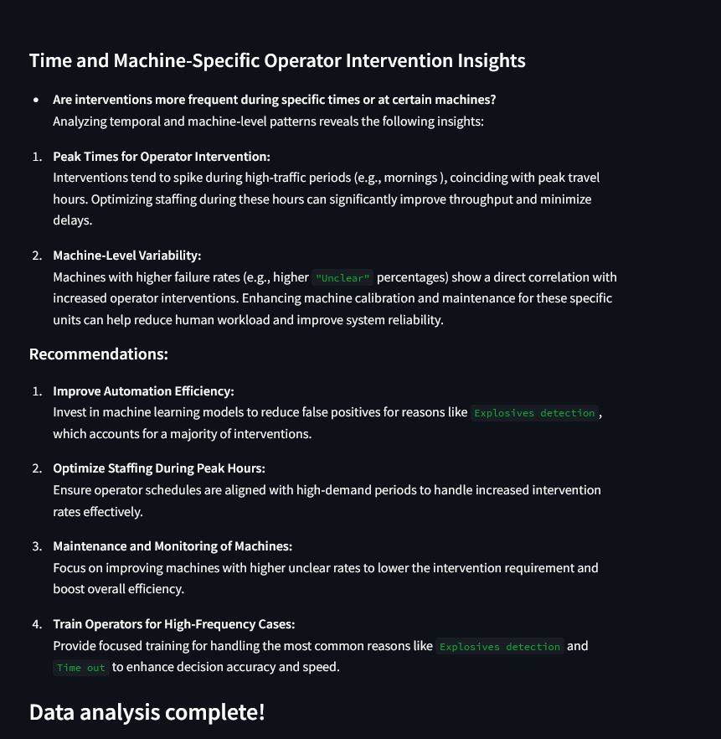

**3 - Why This Method?**  
I believe this approach best aligns with the project’s objective of systematically analysing the data and delivering a comprehensive report. The use of a Streamlit app ensures accessibility and interactivity while also demonstrating my proficiency with analytical tools and my ability to communicate insights effectively.

***For security reasons, I ensured that the repository containing the Streamlit app’s Python file and the related data remains private.***

**4 -** **Statistical Methodologies and Visualizations**  
To thoroughly analyse the data and address the problem scenario, I employed various statistical methodologies throughout the report. Additionally, I utilized diverse plots and graphs to visualize the insights effectively. These include bar charts, scatter plots, line graphs and more. Each visualization is designed to highlight key findings and support a clear understanding of the underlying data trends and patterns.

**5 - Visualization Recommendation**  
***I highly recommend viewing the report in the Streamlit app using a web browser with a dark theme. This enhances the visualization experience by improving contrast and making the insights more visually appealing.***

Please feel free to reach out if you have any questions or require further clarification.

I look forward to your feedback and appreciate the opportunity to contribute to Vanderlande.

Best regards

Cem Saydam